**Lime Tree & Sinnott Healthcare New Patient Registration Form - Adult**

**Personal Information**

|  |  |  |  |  |  |  |
| --- | --- | --- | --- | --- | --- | --- |
| Title: | Mr [ ] Master [ ] Mrs [ ] Miss [ ] Ms [ ] | | | | | |
| First Name(s): |  | | | | | |
| Surname: |  | | | | | |
| Date of Birth: |  | | | | | |
| Full Address:  Full Postcode: |  | | | | | |
| Contact Numbers: | **Home** | | **Mobile** | | **Work** | |
| Email Address: |  | | | | | |
| Marital Status: | Single [ ] | Married [ ] | | Widowed [ ] | | Separated [ ] |
| Occupation: |  | | | | | |
| Main Spoken Language: |  | | | | | |

Do you consent to be contacted by email? Yes [ ] No [ ]

Do you consent to be contacted by text? Yes [ ] No [ ]

**How do you define your sexuality** (please circle):

Heterosexual Bisexual Gay/Lesbian Other

**Religion** (please circle):

Buddhist Christian Hindu Jewish Muslim Sikh None

Any other please state …………………………………………………………

**What is your Country of origin**:...............................................................................

**Which ethnic group do you feel you belong to?** (please circle)

White: A British

B Irish

C Other white (please specify)………………

Mixed: D White & Black Caribbean

E White & Black African

F White & Asian

G Other Mixed (please specify)……………….

Asian/British Asian: H Indian

I Pakistani

J Bangladeshi

K Other Asian (please specify)………………..

Black or Black British: L Caribbean

M African

N Other Black (please specify)………………...

Other ethnic categories: O Chinese

P Any Other

Q Not Stated

**NEXT OF KIN IN THE UK** ………………………………….......................................... **M [ ] F [ ]**

**CONTACT NUMBER**:…………………...……….....................................................

**RELATIONSHIP (WIFE, HUSBAND, PARTNER, CHILD, MOTHER, FATHER, FOSTER PARENT, GRANDPARENT, FRIEND, NEIGHBOUR, OTHER)………………………………………**

**REGISTERED HERE? YES [ ] NO [ ]**

**ARE YOU A CARER YES NO PLEASE CIRCLE**

**HELP IS AVAILABLE FROM WALTHAM FOREST CARERS ASSOCIATION PLEASE ASK AT RECEPTION**

**PREVIOUS GP’S NAME & ADDRESS**

...............................................................................................................................

...............................................................................................................................

______________________________________________________________________

***CURRENT MEDICATION***

***PLEASE BRING YOUR COMPUTER PRINT OUT OF REPEAT PRESCRIPTION FROM PREVIOUS GP***

***IF YOU WOULD LIKE YOUR PRESCRIPTION SENT ELECTRONICALLY, PLEASE GIVE US THE NAME AND LOCATION OF YOUR PREFERRED PHARMACY.***

_______________________________________________________________________

**ANY KNOWN ALLERGIES** (Please list any allergies you have to drugs, medicines or other substances and what happens e.g. rash/swelling.)

_______________________________________________________________________

|  |  |
| --- | --- |
| ***HEIGHT*** | *WEIGHT* |

_______________________________________________________________________

________________________________________________________________________

**EXERCISE (PLEASE TICK BOX)**

|  |  |
| --- | --- |
| Exercise impossible □ | Avoids Exercise □ |
| Enjoys light exercise □ 🡪 | i.e swimming, walking  How often per week………………….. |
| Moderate exercise □ 🡪 | What type of exercise ?  How often per week………………….. |
| Aerobic exercise □ 🡪 | How often per week………………….. |

**FAMILY HISTORY HAVE ANY OF YOUR RELATIVES SUFFERED FROM THE FOLLOWING PLEASE √ YES OR NO**

**(*PLEASE STATE RELATIONSHIP)***

**RELATION YES NO**

|  |  |  |  |
| --- | --- | --- | --- |
| **Heart Disease under age 60** |  |  |  |
| **Heart Disease over the age of 60** |  |  |  |
| **Stroke** |  |  |  |
| **Hypertension** |  |  |  |
| **Diabetes** |  |  |  |
| **Cancer** |  |  |  |
| **Epilepsy** |  |  |  |
| **Asthma** |  |  |  |
| **Breast Cancer** |  |  |  |
| **Ovarian Cancer** |  |  |  |
| **Sickle Cell** |  |  |  |
| **Glaucoma** |  |  |  |
| **Mental Health problems** |  |  |  |
| **OTHER** |  |  |  |

**SMOKING INFORMATION**

Choose **ONE** column that applies to you and fill it in.

|  |  |  |
| --- | --- | --- |
| **NEVER SMOKED** | **EX-SMOKER** | **CURRENT SMOKER** |
| If you have never smoked please tick the box below:  [ ] **Never Smoked** | Age or Date you started smoking: _ _ _ _ _ _ _ _ _ _ _ _ _ _ _ _ _ _  Age or Date you stopped smoking: _ _ _ _ _ _ _ _ _ _ _ _ _ _ _ _ _ _ _  What did you smoke?  [ ] Roll ups  [ ] Cigarettes  [ ] Cigars  [ ] Pipe  [ ] Other _ _ _ _ _ _ _ _ _ _ _ _ _  Maximum you smoked per day:  _ _ _ _ _ _ _ _ _ _ _ _ _ _ _ _ _ _  What helped you stop smoking?  _ _ _ _ _ _ _ _ _ _ _ _ _ _ _ _ _ _ _ | Age or Date you started smoking: _ _ _ _ _ _ _ _ _ _ _ _ _ _ _ _ _ _ _  What do you smoke?  [ ] Roll ups  [ ] Cigarettes  [ ] Cigars  [ ] Pipe  [ ] Other _ _ _ _ _ _ _ _ _ _ _ _ _  Maximum you smoke per day:  _ _ _ _ _ _ _ _ _ _ _ _ _ _ _ _ _ _ _  Would you like to give up smoking?  [ ] YES [ ] NO  If YES would you like help to quit?  [ ] YES [ ] NO |

**YOUR PAST MEDICAL HISTORY** (Please list any serious illnesses, operations and accidents with dates PLEASE √ questions which apply to you

Do you suffer from any of the following: -

Stroke Angina Heart Attack Hypertension (High Blood) Pressure

Last BP check………………. Diastolic……./systolic……..

Diabetes Date of Annual Review……………or last follow up………….

Date of Diagnosis……………..

Epilepsy date of last fit………….Frequency of fits………………………

Asthma When did you do your last Peak Flow Reading…..…….

What was it ………..Have you been taught inhaler techniques Yes No

When was your last asthma review…………………

COPD Have you had a spirometry test? No Yes Date………..

Hypothyroidism Date of last blood test for TSH………………

Cancer when diagnosed………………..Review date…………

Mental Health problems If yes do you attend any Centre’s…………………...

Name of Centre……………………………………………………………………

Sickle Cell Yes No Thalassaemia Yes No

**OPERATIONS:-**

**OTHER ILLNESSES:-**

**VACCINATIONS**

When did you last have the following vaccinations?

Tetanus……………………. Typhoid……………………

Polio ……………………. Hepatitis A………………

Hepatitis B……………….. MENINGITIS …………………..

_______________________________________________________________________

**MEN ONLY**

Are you aware of testicular cancer self-examination? Yes No

leaflet given

Have you any urinary/prostate problems? Yes No

**WOMEN ONLY**

**Have you had a smear test**? Yes No

IF NO DO YOU AGREE TO HAVE THE TEST DONE Yes No

CYTOLOGY LEAFLET GIVEN

IF NO - INFORMED DISSENT LETTER GIVEN/SIGNED

If Yes date of last test…………………

Result of Test………………………………………..

Where was the smear taken………………………..

Have you had any abnormal smears results…Yes No

(please tick)

GP Surgery Hospital Family Planning Clinic

**Contraception Advice**

If using depot when is your next injection due? Date…………………………..

Ensure you make an appointment with the nurse

Have you had a Hysterectomy Yes No if yes please give date………………………..

Do you take HRT Yes No

Are you aware of self-examination of the breast Yes No

Breast awareness leaflet given

Date of your last mammogram (if appropriate) ………..

Number of births: ………….. Number of miscarriages: ………..

**FLU VACCINATION IF YOU ARE AGED 65 & OVER, OR IN AN AT RISK GROUP**

**i.e. DIABETIC, CHD, ASTHMA, COPD**

Do you usually have a FLU JAB YES NO

Age 65 + have you had a PNEUMOVAX VACCINE YES NO

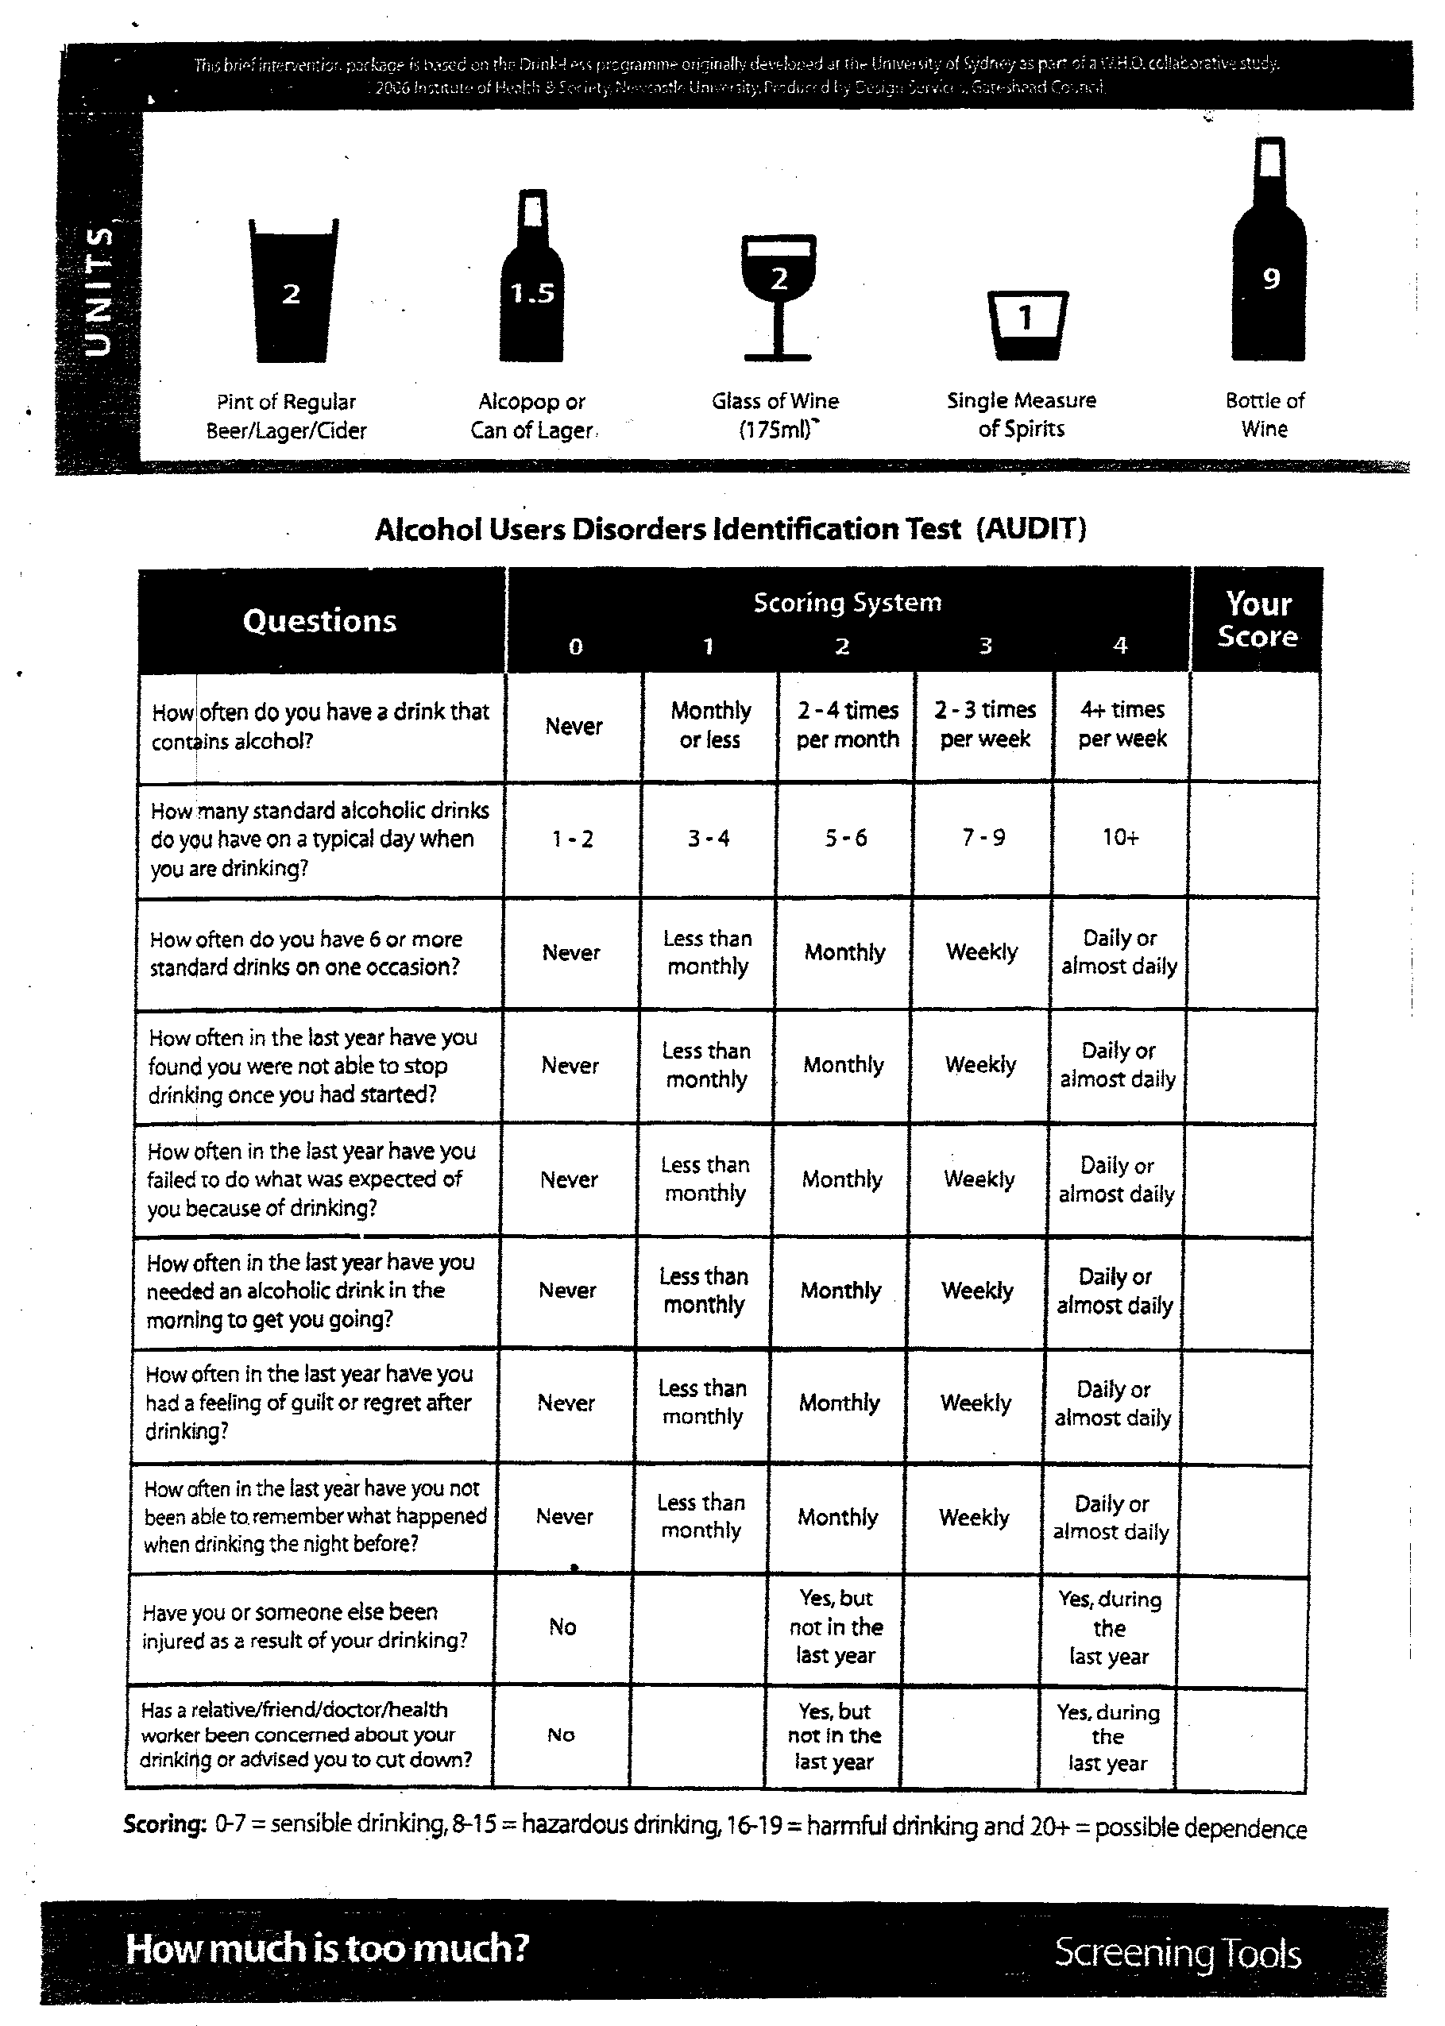



**LIME TREE & Sinnott Healthcare**

**12B Sinnott Road**

**Walthamstow**

**E17 5QB**

**Tel: 020 8709 3140 Fax: 020 8703 3146**

**CONSENT TO OBTAIN MEDICAL RECORDS**

**Please complete this form if you have had a previous doctor in the U.K.**

Full Name:………………………………………………………………….

DOB:…………………………………………………………………………

Current Address: …………………………………………………………..

………………………………………………………………………………..

Previous Address:………………………………………………………….

……………………………………………………………………………….

Previous U.K. GP Name:………………………………………………….

Address: …………………………………………………………………….

Phone: ………………………………………………………………………

Fax:…………………………………………………………………………...

I, the undersigned, hereby give my permission and request you to release full details and copies of my General Practitioners Records, both past and present and any other medical records as may be required to The Lime Tree Surgery.

I can confirm that this information is not required in respect of a claim for medical negligence.

**I AM THE PATIENT/PARENT/LEGAL GUARDIAN OF THE ABOVE** (please delete as appropriate).

SIGNATURE DATE

**SURGERY USE ONLY**

|  |  |  |
| --- | --- | --- |
|  | Initials | Date |
| Medical Card (If Applicable) |  |  |
| GSM1 Form (If Applicable) |  |  |
| Proof of address? |  |  |
| Photo ID? |  |  |
| Red Book (If Applicable) |  |  |

**PLEASE REPRINT NAME, ADDRESS, DOB, TELEPHONE NUMBERS ETC IF UNCLEAR.**

………………………………………………………………………………………………………………………………………………………………………………………………………………………………………………………………………………………………………………………………………………………………………………………………………………………………………………………………………………………………………….

………………………………………………………………………………………………………………………….

………………………………………………………………………………………………………………………….

**Summary Care Record**

1. **Do you wish to have a SCR created. (Please circle) Yes / No / Need more Time**

**Introduction to Summary Care Records**

The NHS in England is now using an electronic record called the Summary Care Record (SCR), which is being used to support patient care.

All the settings where you receive health care keep their own medical records about you. These places can often only share information from your records by letter, fax or phone. At times, this can delay information sharing and this can impact decision making and slow down treatment.

The Summary Care Record is a copy of key information held in your GP record. It provides authorised healthcare staff with faster, secure access to essential information about you - when you need unplanned care or when your GP practice is closed. The availability of Summary Care Records will improve the safety and quality of your care.

**Where can I get more information?**

For more information about Summary Care Records you can

1. visit www.nhscarerecords.nhs.uk
2. phone the Health and Social Care Information Centre on 0300 303 5678

The NHS Care Record Guarantee is available online at

**http://systems.hscic.gov.uk/scr/usefuldocuments**

If you wish to Opt Out the Form is available on line at

**http://systems.hscic.gov.uk/scr/usefuldocuments**

**OUR STAFF WILL NOT BE ABLE TO ANSWER QUESTIONS RELATED TO THE** **SUMMARY CARE RECORD**.

**CARE.DATA**

**Sharing your data be informed**

Where can I get more information?

Leaflets in other languages and formats are available from our website.

For more information, including a list of frequently asked questions (FAQs), please go to the website at www.nhs.uk/caredata.

You can also get further information from the website at www.hscic.gov.uk.

**Thank you for taking the time to fill in this registration form.**

**Lime Tree & Sinnott Health Care**

**Do you have an opinion on how our services can be improved?**

*We would like to hear them!*

We are currently updating out list of patients who would like to be part of our **Patient Participation Group.**

This means that we will routinely get in touch with you to gather your opinions, criticisms and ideas to help us better our service.

At Lime Tree and Sinnott Health Care, we endeavour to provide the highest level of healthcare for our patients, and we would like your help in doing that.

[](https://thenounproject.com/term/check-box-blank/620634) I am interested in joining the PPG and give consent to the practice to contact me via email and mobile.

Full Name: _______________________ D.O.B: _________

Email Address: ___________________________________

Mobile Number: __________________________________

Thank you



*Under the Data Protection Act 1998, we will never share any of your personal information on with other companies or organizations unless authorized to do so by yourself. All information that we gather will be kept securely within your medical records. For any information, please speak to a member of staff.*

**Application for online access to patient facing services**

TO BE COMPLETED IN BLOCK LETTERS.

|  |  |
| --- | --- |
| Surname | Date of birth |
| First name | |
| Address      Postcode | |
| Email address | |
| Telephone number | Mobile number |

I wish to have access to the following online services (please tick all that apply):

|  |  |
| --- | --- |
| Booking appointments | 🞏 |
| Requesting repeat prescriptions | 🞏 |

I wish to access my medical record online and understand and agree with each statement (tick)

|  |  |
| --- | --- |
| 1. I have read and understood the information leaflet provided by the practice | 🞏 |
| I will be responsible for the security of the information that I see or download | 🞏 |
| If I choose to share my information with anyone else, this is at my own risk | 🞏 |
| I will contact the practice as soon as possible if I suspect that my account has been accessed by someone without my agreement | 🞏 |
| If I see information in my record that is not about me or is inaccurate, I will contact the practice as soon as possible | 🞏 |

|  |  |
| --- | --- |
| Signature | Date |

**For practice use only**

|  |  |  |  |  |
| --- | --- | --- | --- | --- |
| Patient NHS number | | EMIS Number | | |
| Identity verified by  (initials) | Date | Method  Photo ID and proof of residence 🞏 | | |
| Authorised by | | | | Date |
| Date account created | | | | |
| Date passphrase sent | | | | |
| Level of record access enabled  Contractual minimum √  Other……………………. ……… | | | Notes / explanation | |